Types of Factoring
Before you factor any expression, you must always check for and factor out a
Greatest Common Factor(GCF)!

 | Looks Like | How to Factor | Examples
GCF (Two Terms) | ax² - bx | Factor out what is common to both terms (mentally or list method)  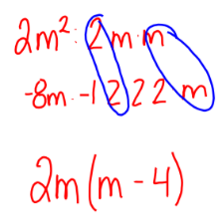 | x² + 5x = x(x + 5)  18x² – 6x = 6x(3x – 1)  -9x² – x = -x(9x + 1)
A = 1 | x² + bx + c | Think of what two numbers multiply to get the c term and add to get the b term (Think of the diamond). You also need to think about the signs:  x² + bx + c = (x + #)(x + #)  x² – bx + c = (x - #)(x - #)  x² – bx – c/x² + bx – c = (x + #)(x - #) | x² + 8x + 7 = (x + 7)(x + 1)  x² – 5x + 6 = (x – 2)(x – 3)  x² – x – 56 = (x + 7)(x – 8)
A not 1 | ax² + bx + c | Area Model/Box Method: 2x² + 3x - 2  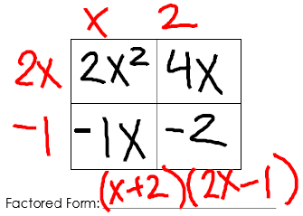 | 9x² – 11x + 2 = (9x – 2) (x – 1)  2x² + 15x + 7 = (2x + 1)(x + 7)  3x² – 5x – 28 = (2x + 7)(x – 4)
Difference of Two Squares | x² – c | Both your a and c terms should be perfect squares and since there is no b term, it has a value of 0. You must also be subtracting the a and c terms. Your binomials will be the exact same except for opposite signs.  Difference of Squares  a² – b² = (a + b)(a – b) | x² – 9 = (x + 3)(x – 3)  x² – 100 = (x + 10)(x – 10)  4x² – 25 = (2x + 5)(2x – 5)
Perfect Square Trinomials | x² + bx + c  “c” is a perfect square  “b” is double the square root of c | Factor like you would for when a = 1 | x² – 6x + 9 = (x – 3)(x – 3)  = (x – 3)²  x² + 16x + 64 = (x + 8)(x + 8)  = (x + 8)²

